

*Report*

*On*

**Software Engineering**

**20MCA21**

**Bankruptcy** **– Assignment 1**

***Submitted in Partial Fulfillment of the Requirement***

***for the II Semester MCA***

**MASTER OF COMPUTER APPLICATIONS**

**By**

|  |  |
| --- | --- |
| **1RV21MC003** | **ADARSH MORYE** |
| **1RV21MC016** | **ANURAG BHATT** |

**Under the Incharge**

**of**

*D*r*. Chandrani Chakravorty*

Department of Master of Computer Applications

RV College of Engineering®, Mysuru Road

RV Vidyanikethan Post, Bengaluru – 560059

**INDEX page**

|  |  |  |
| --- | --- | --- |
| **Sl.NO** | **Particulars** | **Page NO** |
|  | **Problem defintion** |  |
|  | **SRS Document** |  |

**Problem Definition**

Bankruptcy is a state of financial distress in which a business or person is unable to pay their bills. It can lead to Bankruptcy proceedings, in which legal action will be taken against the insolvent person or entity, and asset may be liquidated to pay off outstanding debts. Business owners may contact creditors directly and restructure debts into more manageable installments. Creditors are typically amenable to this approach because they desire repayment, even if the repayment is on a delayed schedule.

If a business owner plans on reconstructing the company’s debt, they assemble a realistic plan showing how they can reduce company overhead and continue carrying out business operations. The owner creates a proposal detailing how the debt may be restructured using cost reductions or other plans for support. The proposal shows creditors how the business may produce enough cash flow for profitable operations while paying its debts.

The Supreme Court has consistently stated that the bankruptcy laws exist to help the individual get a fresh financial start. Bankruptcy can legally and permanently eliminate debts you cannot pay and restructure your finances for a fresh financial start. Call today and speak with an experienced bankruptcy attorney to learn how bankruptcy can help you.

There are numerous factors that can contribute to a person's or company’s insolvency. A company’s hiring of inadequate accounting or human resources management may contribute to insolvency. For example, the accounting manager may improperly create and/or follow the company’s budget, resulting in overspending. Expenses add up quickly when too much money is flowing out and not enough is coming into the business.

Rising vendor costs can also contribute to insolvency. When a business has to pay increased prices for goods and services, the company passes along the cost to the consumer. Rather than pay the increased cost, many consumers take their business elsewhere so they can pay less for a product or service. Losing clients results in losing income for paying the company’s creditors.

Lawsuits from customers or business associates may lead a company to insolvency. The business may end up paying large amounts of money in damages and be unable to continue operations. When operations cease, so does the company’s income. Lack of income results in unpaid bills and creditors requesting money owed to them.

Some companies become insolvent because their goods or services do not evolve to fit consumers’ changing needs. When consumers begin doing business with other companies offering larger selections of products and services, the company loses profits if it does not adapt to the marketplace. Expenses exceed revenues and bills remain unpaid.

So our project is Based on analyzing the risk a bank consider to issue loan to the business or the person who has filled bankruptcy also help the business to understand the reason which lead to the company to file the bankruptcy.

**SRS (Software Requirements Specification) Document**

**Table of Contents**

1. **Introduction……………………………………………………………………**
   1. **Purpose………………………………………………………………………………..**
   2. **Scope…………………………………………………………………………………..**
   3. **Intended Audience……………………………………………………………………**
   4. **Definitions, Acronyms and Abbreviations……………………………….…………**
   5. **References…………………………………………………………………………….**
   6. **Document Conventions ………………………………………………………………**
   7. **Overview……………………………………………………………………………….**
2. **Overall Description.……………………………………………………………**

**2.1 Product Perspective……………………………………………………………………**

**2.1.1 System Interface………………………………………………………………**

**2.1.2 User Interface…………………………………………………………………**

**2.1.3 Hardware Interface…………………………………………………………..**

**2.1.4 Software Interface…………………………………………………………….**

**3 System Design**

**3.1 Architectural Design …………………………………………………………………**

**3.2Activity Diagram………………………………………………………………………**

**3.3 DFD level 0……………………………………………………………………………**

**3.4 Class Diagram…………………………………………………………………………**

**3.5 Sequence Diagram……………………………………………………………………..**

# 4 Software Testing

### 4.1Unit Testing………………………………………………………………………………

### 4.2 Integration Testing……………………………………………………………………..

**1. Introduction**

**1.1 Purpose**

The purpose of this document is to understand how Business or person might perform in the near future and Data model to do analysis on why the business is filing the Bankruptcy and understanding how might perform to reduce the bankruptcy in future. This document comprises of the problem statement, requirements, functional description, etc. Necessary to explain the functionality of the software being built. The focus here is to reduce the number of bankruptcy, big data helps us to do that.

**1.2 Scope**

The software system will be an online website for the banks and the company who can visit to check the financial balance sheet of a company. Bank check so as to give the loan to the business by doing the risk analysis. Business check this to check the reason and analyze the reason what is the reason for the company are filing the bankruptcy.

**1.3 Intended Audience**

This project is a tool used for analyzing the risk of providing the Loan to the business who is about to file the bankruptcy. This has been implemented under the guidance of college professors. This project is useful for the bank offering loan and as well as to the business filing bankruptcy

**1.4 Definitions, Acronyms and Abbreviations.**

**1.4.1 BDA**

Big Data Analytics[2].

**1.4.2 Hadoop**

Apache Hadoop[7] is an open-source framework that is used to efficiently store and process large datasets ranging in size from gigabytes to petabytes of data.

**1.4.3 HDFS**

The Hadoop Distributed File System (HDFS)[6] is a distributed file system designed to run on commodity hardware.  HDFS exposes a file system namespace and allows user data to be stored in files. Internally, a file is split into one or more blocks and these blocks are stored in a set of DataNodes. The NameNode executes file system namespace operations like opening, closing, and renaming files and directories

**1.4.4 MapReduce**

MapReduce is a processing technique and a program model for distributed computing based on java. The MapReduce algorithm contains two important tasks, namely Map and Reduce. Map takes a set of data and converts it into another set of data, where individual elements are broken down into tuples (key/value pairs). Secondly, reduce task, which takes the output from a map as an input and combines those data tuples into a smaller set of tuples.

**1.4.5 PIG**

Pig is a high-level platform or tool which is used to process the large datasets. It provides a high-level of abstraction for processing over the MapReduce[2]. It provides a high-level scripting language, known as *Pig Latin* which is used to develop the data analysis codes.

**1.4.6 Feature**

In BDA a feature is a measurable property of the object you're trying to analyze.

**1.4.7 Dataset**

A data set is a structured collection of data points related to a particular subject. A collection of related data sets is called a database[5].

Data sets can be tabular or non-tabular. Tabular data sets contain structured data that is organized by rows and columns. Non-tabular data sets contain unstructured data contained by brackets.

**1.4.8 HIVE**

Hive[2] is a data warehouse system which is used to analyze structured data. It is built on the top of Hadoop. It was developed by Facebook. Using Hive, we can skip the requirement of the traditional approach of writing complex MapReduce programs. Hive supports Data Definition Language (DDL)[2], Data Manipulation Language (DML)[2], and User Defined Functions (UDF)[2].

**1.4.9 HQL**

Hive Query Language[4] is a query language in Apache Hive for processing and analyzing structured data. It separates users from the complexity of Map Reduce programming.

**1.5 References**

1. https://www.datarobot.com/wiki/feature/
2. https://www.techopedia.com/definition/3348/data-set-ibm-mainframe.
3. [https://www.datatobiz.com/blog/datasets-in-big-data/#:~:text=Dataset%20is%20a%20collection%20of,Image%20or%20video%20classification](https://www.datatobiz.com/blog/datasets-in-big-data/" \l ":~:text=Dataset is a collection of,Image or video classification)
4. [https://www.guru99.com/hive-query-language-built-operators-functions.html#:~:text=Hive%20Query%20Language%20(HiveQL)%20is,and%20schema%2C%20to%20ease%20learning](https://www.guru99.com/hive-query-language-built-operators-functions.html" \l ":~:text=Hive Query Language (HiveQL) is,and schema%2C to ease learning).
5. https://www.kaggle.com/datasets/fedesoriano/company-bankruptcy-prediction
6. https://www.ibm.com/in-en/topics/hdfs
7. https://hadoop.apache.org/
8. <https://www.guru99.com/er-diagram-tutorial-dbms.html>
9. <https://nulab.com/learn/software-development/what-is-an-architecture-diagram-and-why-do-you-need-one/>https://www.edrawmax.com/context-diagram/

**1.5 Naming Convection**

The font used for the Document is TIMES NEW ROMAN. The bold text are headlines or the main topics, font size used for the heading is 16 and the font size for the rest of the text is 14.

**1.6 Overview**

This document is subject to modifications as we are still working on the solution to the problem statement, and hence will require refinements. Requirements, structure of final outcome may be modified as per changes to the features, dataset, BDA model, etc.

**2 Overall Description**

**2.1 Product Prospective**

* + 1. To give the Details of the companies who filed the bankruptcy
    2. To Net Value of all the Shares.
    3. To Income without Tax and with Tax
    4. To Total Amount of the Loan Business is Paying.
    5. To display the net Sales of the the company who is bankrupt.
    6. To Display the net sales of the Company who is not bankrupt.
    7. To display the expenditure of the Company
    8. To display the sum of Current Asset and total Asset.
    9. To display the operating profit of the person.

**2.1.1.1 System Interface**

Pig Latin and MapReduce along with java is the primary interface where the user can interact to fetch the related information. Terminal in the case of initiating a grunt shell on the terminal.

**2.1.1.2 User Interface**

A regular and frequently used database, PIG scripts or Terminal interface can be used to retrieve information on the performers who appear on a specific attribute or comparative analysis. Based on the specifications he wants the system to meet, the user will be able to retrieve reliable information. To retrieve accurate information, the user utilizes queries.

**2.1.1.3 Hardware Interface**

**a) Server side**

Pig Scripts will be Running on a HDFS which is listening on the on terminal using Grunt shell.

**b) Client side**

Monitor screen – the software shall display information to the user via the monitor screen

Mouse – the terminal shall interact with the movement of the mouse and the mouse buttons. The mouse shall activate areas for data input, command buttons and select options from menus.

Keyboard – the terminal shall interact with the keystrokes of the keyboard. The keyboard will input data into the model.

**2.1.1.4 Software Interface**

**a) Server side**

An Apache web server or local host or VS Code Live Server will accept all requests from the client and forward it accordingly.

**b) Client side**

An OS which is capable of running a modern web browser which supports JavaScript and HTML5.

**2.1.1.5 Communication Interfaces**

The HTTP or HTTPS protocol(s) will be used to facilitate communication between the client and server

**2 NONFUNCTIONAL REQUIREMENTS**

**2.11 PERFORMANCE REQUIREMENTS**

The steps involved to perform the implementation of airline database are as listed below.

**A) E-R DIAGRAM**

The E-R Diagram[8] constitutes a technique for representing the logical structure ofa database in a pictorial manner. This analysis is then used to organize data as a relation, normalizing relation and finally obtaining a relation database.

**ENTITIES:**Which specify distinct real-world items in an application.

**PROPERTIES/ATTRIBUTES:** Which specify properties of an entity and relationships.

**RELATIONSHIPS:** Which connect entities and represent meaningful dependencies between them.

the diagram shows the ER diagram of Bankruptcy database

**B) NORMALIZATION:**

The basic objective of normalization is to reduce redundancy which means that information is to be stored only once. Storing information several times leads to wastage of storage space and increase in the total size of the data stored. If a database is not properly designed it can give rise to modification anomalies.

Modification anomalies arise when data is added to, changed or deleted from a database table. Similarly, in traditional databases as well as improperly designed relational databases, data redundancy can be a problem. These can be eliminated by normalizing a database. Normalization is the process of breaking down a table into smaller tables. So that each table deals with a single theme. There are three different kinds of modifications of anomalies and formulated the first, second and third normal forms (3NF) is considered sufficient for most practical purposes. It should be considered only after a thorough analysis and complete understanding of its implications.

**2.4 SAFETY REQUIREMENTS**

If there is extensive damage to a wide portion of the database due to catastrophic failure, such as a disk crash, the recovery method restores a past copy of the database that was backed up to archival storage (typically tape) and reconstructs a more current state by reapplying or redoing the operations of committed transactions from the backed up log, up to the time of failure.

**2.5 SECURITY REQUIREMENTS**

Security systems need database storage just like many other applications. However, the special requirements of the security market mean that vendors must choose their database partner carefully.

**2.6 SOFTWARE QUALITY ATTRIBUTES**

**AVAILABILITY**:The flight should be available on the specified date and specified time as many customers are doing advance reservations.

**CORRECTNESS**:The flight should reach start from correct start terminal and should reach the correct destination.

**MAINTAINABILITY**:The administrators and flight in chargers should maintain correct schedules of flights.

**USABILITY**:The flight schedules should satisfy a maximum number of customers needs.

**3 System Design**

## 3.1 Architectural Design

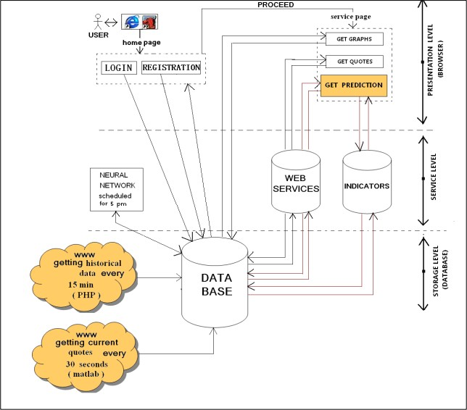

**3.2Activity Diagram**

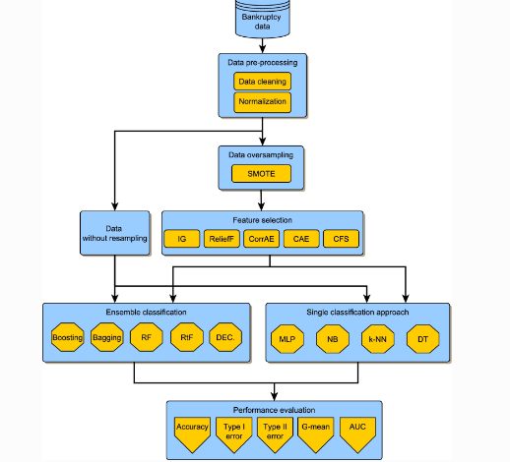

**3.3 DFD level 0**

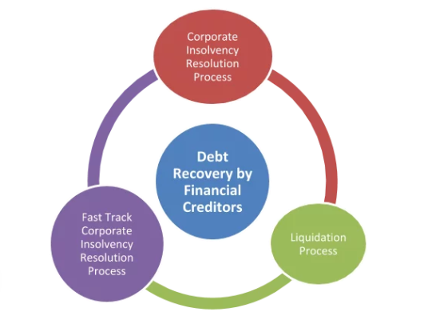

**3.4 Class Diagram**

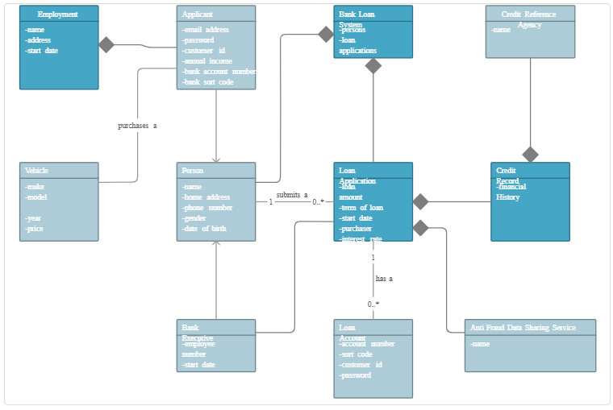

**3.5 Sequence Diagram**

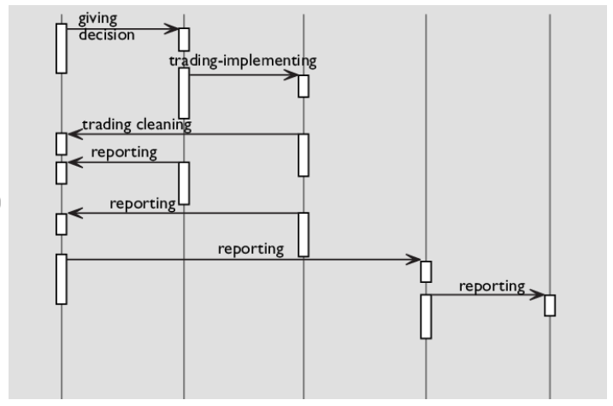

**3.6 Use Case Diagram**

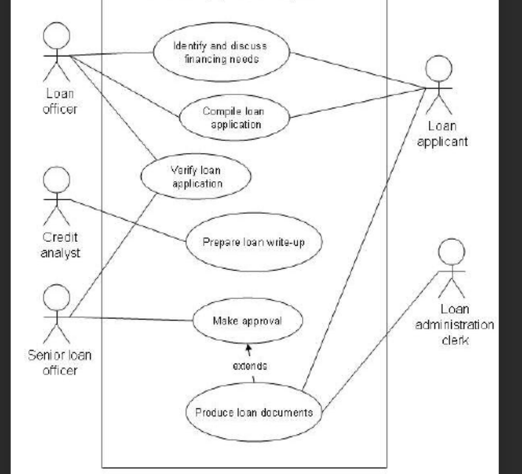

# 4 Software Testing

### 4.1Unit Testing

The smallest chunk of code that can be logically separated in a system is called a unit, and a unit test is a method of testing a unit. That is a method, a function, a subroutine, or a property in the majority of programming languages. The definition's isolated portion is crucial. Michael Feathers, the author of "Working Effectively with Legacy Code," claims that such tests are not unit tests if they depend on other systems: "If it involves system configuration, can't be run concurrently with any other test, talks to the database, talks via the network, touches the file system."

Test case 1: Testing for the data integrity

when the analyser is provided with data, and with the given data the results are accurate or are there in consistencies that needs to checked, if the details that are being put out after the data dump are incorrect and inconsistent then the system is considered to be a failure

Test case 2: Testing if the data is properly displayed

this test case involves if the data that is processed after the query is properly displayed to the user or not ,if the data that is processed with such huge power with lot of nodes at the backend then the system has failed its purpose

### 4.2 Integration Testing

The Integration testing is done to test the modules/components when they have been integrated to ensure that they function as intended, i.e. to test the modules that have no problems when used separately and do not have problems when combined. The coupling of numerous modules that are closely coupled with one another is required when testing a large application utilising the black box testing technique. For testing these kinds of scenarios, we can use the concepts of the integration testing technique.

Test Case 1: Total data processing

If the given data is processed and exported properly and the data being displayed is accurate with the user given data then the modules of two-unit testing have or can be considered as successful integration of the system

### 4.3 System Testing

The System testing involves evaluating the entire system. The system's functionality is tested by integrating all of the modules and components to see if it performs as intended. Following Integration Testing comes System Testing. This is crucial for producing a high-quality product.

Test case 1:

The system is checked for any errors while detecting, preprocessing, recognizing or recording the Stock data in the Cluster. Failing after integrating all the modules in the system results in failing the system testing test case. The Cluster should contain the processed data of the file that has been dumped by the user for analysis.